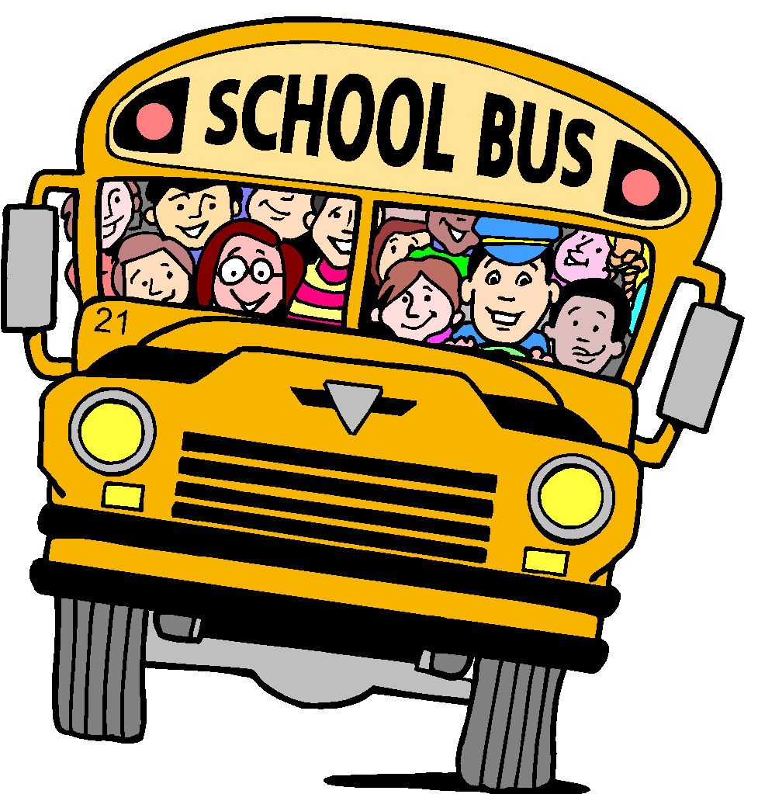
Mrs. White’s Testing Newsletter Return Slip
If you have read and reviewed the newsletter with your student, please sign and return to Mrs. White.
Students that review the newsletter with their parents and return this form signed will be given a special surprise when it’s returned.

Students Name:________________________________________

I have read and reviewed my students’ scores and the newsletter with my child.

Parents Signature:_____________________________________

